Sennheiser and Q-SYS Now Certified to Bring Seamless Audio and Control Experiences to Cisco’s Collaboration Devices

Sennheiser’s TCC 2 ceiling microphone and the Q-SYS Core Nano processor can now be integrated with Cisco’s Collaboration Devices to deliver a complete meeting solution

Wedemark, Germany, February 20, 2024 – Sennheiser, the first choice for advanced audio technology that makes collaboration and learning easier, is pleased to announce that its combined solution with Q-SYS, a cloud-manageable audio, video, and control (AV&C) Platform, has achieved certification for use with Cisco’s Collaboration Devices.

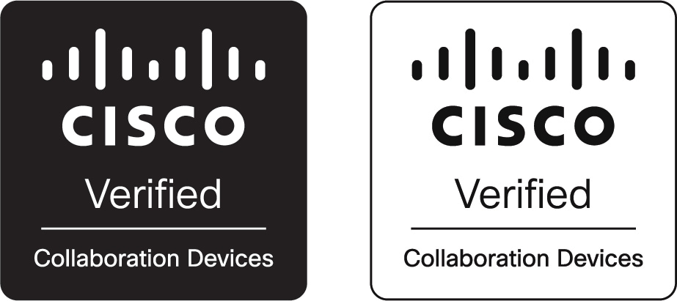

This certification represents the integration of Cisco’s Collaboration Devices with Sennheiser’s TCC 2 and the Q-SYS Core Nano processor, delivering enhanced audio connectivity and intelligent control features for contemporary meeting and learning environments. The Cisco Collaboration Devices serve as the video conferencing engine that brings robust computing power to support a wide range of collaboration scenarios.

Participants using Cisco’s conferencing solutions in a meeting room, lecture hall or collaboration space can experience the superior audio and automatic beamforming capabilities of the TCC 2 with control from Q-SYS and Sennheiser.
The Q-SYS Core Nano audio, video and control (AV&C) processor

“We are excited to partner with Sennheiser to offer a certified end-to-end audio solution for high-impact spaces utilizing Cisco’s conferencing solutions,” says Vic Bhagat, Principal, Alliances, Q-SYS. “This removes the guesswork out of the room design and deployment, while providing end users an enhanced collaboration experience.”

Adapting meeting rooms to hybrid work requires a unique blend of collaboration technology, integrated workflows, and workspace intelligence. The certified integration of Sennheiser and Q-SYS with Cisco’s video bars, room kits and integrated video conferencing systems facilitates a seamless blend of physical and digital workspaces, promoting scalable and flexible collaboration. As s part of the Cisco Collaboration Devices Partner Ecosystem, these solutions ensure participants get the best experience and make integration as seamless as possible.

“With Sennheiser microphones and the Q-SYS Platform meeting Cisco Collaboration Devices stringent requirements for certification, we provide our mutual customers with the best possible audio, video, and control experience,” stated Espen Løberg, Cisco Collaboration Devices VP.

With a coverage of up to 80 m², the TCC 2 is a great solution for large meeting rooms and lecture or collaboration spaces. With its functional square form, the TCC 2 gracefully integrates into the design of modern meeting rooms – simply by replacing a ceiling tile.

Sennheiser’s TeamConnect Ceiling 2

Part of the Sennheiser TeamConnect Family, the TCC 2 is a problem-solver that allows cable free tables and flexible furniture arrangement, while offering all of the TeamConnect Ceiling Solutions benefits like Trusted Sennheiser Audio Quality, efficient setup, brand agnostic integration, simple management and control, a sleek design and a sustainable impact.

“We are thrilled to see our TeamConnect Ceiling 2 microphone and the collaboration with Q-SYS reach new heights through this certification with Cisco Collaboration Devices,” said Charlie Jones, Global Alliance & Partnership Manager, Sennheiser. “By aligning with Cisco’s conferencing technology, we are able to offer robust, seamless integrations into a wide range of collaborative environments, paving the way for more dynamic and effective communication in meeting rooms and learning spaces worldwide.”

Additional information about Cisco Collaboration Devices can be found here https://www.cisco.com/c/en/us/solutions/collaboration/index.html.
For more information about Q-SYS Core Nano, visit https://www.qsys.com/products-solutions/q-sys/processing/core-nano/. To learn more about Sennheiser’s TCC 2 and the complete TeamConnect Ceiling Solutions. go to https://sennheiser.com/teamconnect-ceiling-solutions. Finally, to find technical details about how solutions from these companies work together, visit https://help.webex.com/en-us/article/7sw4gab/Cisco-collaboration-devices-certification-program

About the Sennheiser brand
We live and breathe audio. We are driven by the passion to create audio solutions that make a difference. Building the future of audio and bringing remarkable sound experiences to our customers – this is what the Sennheiser brand has represented for more than 75 years. While professional audio solutions such as microphones, meeting solutions, streaming technologies and monitoring systems are part of the business of Sennheiser electronic GmbH & Co. KG, the business with consumer devices such as headphones, soundbars and speech-enhanced hearables is operated by Sonova Holding AG under the license of Sennheiser.

www.sennheiser.com
www.sennheiser-hearing.com

Global Press Contact

Jeff Horan
+1 860-598-7539
jeffrey.horan@sennheiser.com

